Unit 3 Lab and Challenge: Laura Richardson
- Screenshot #1: Unity Hierarchy & Inspector showing DynamicCube with Rigidbody.
  - 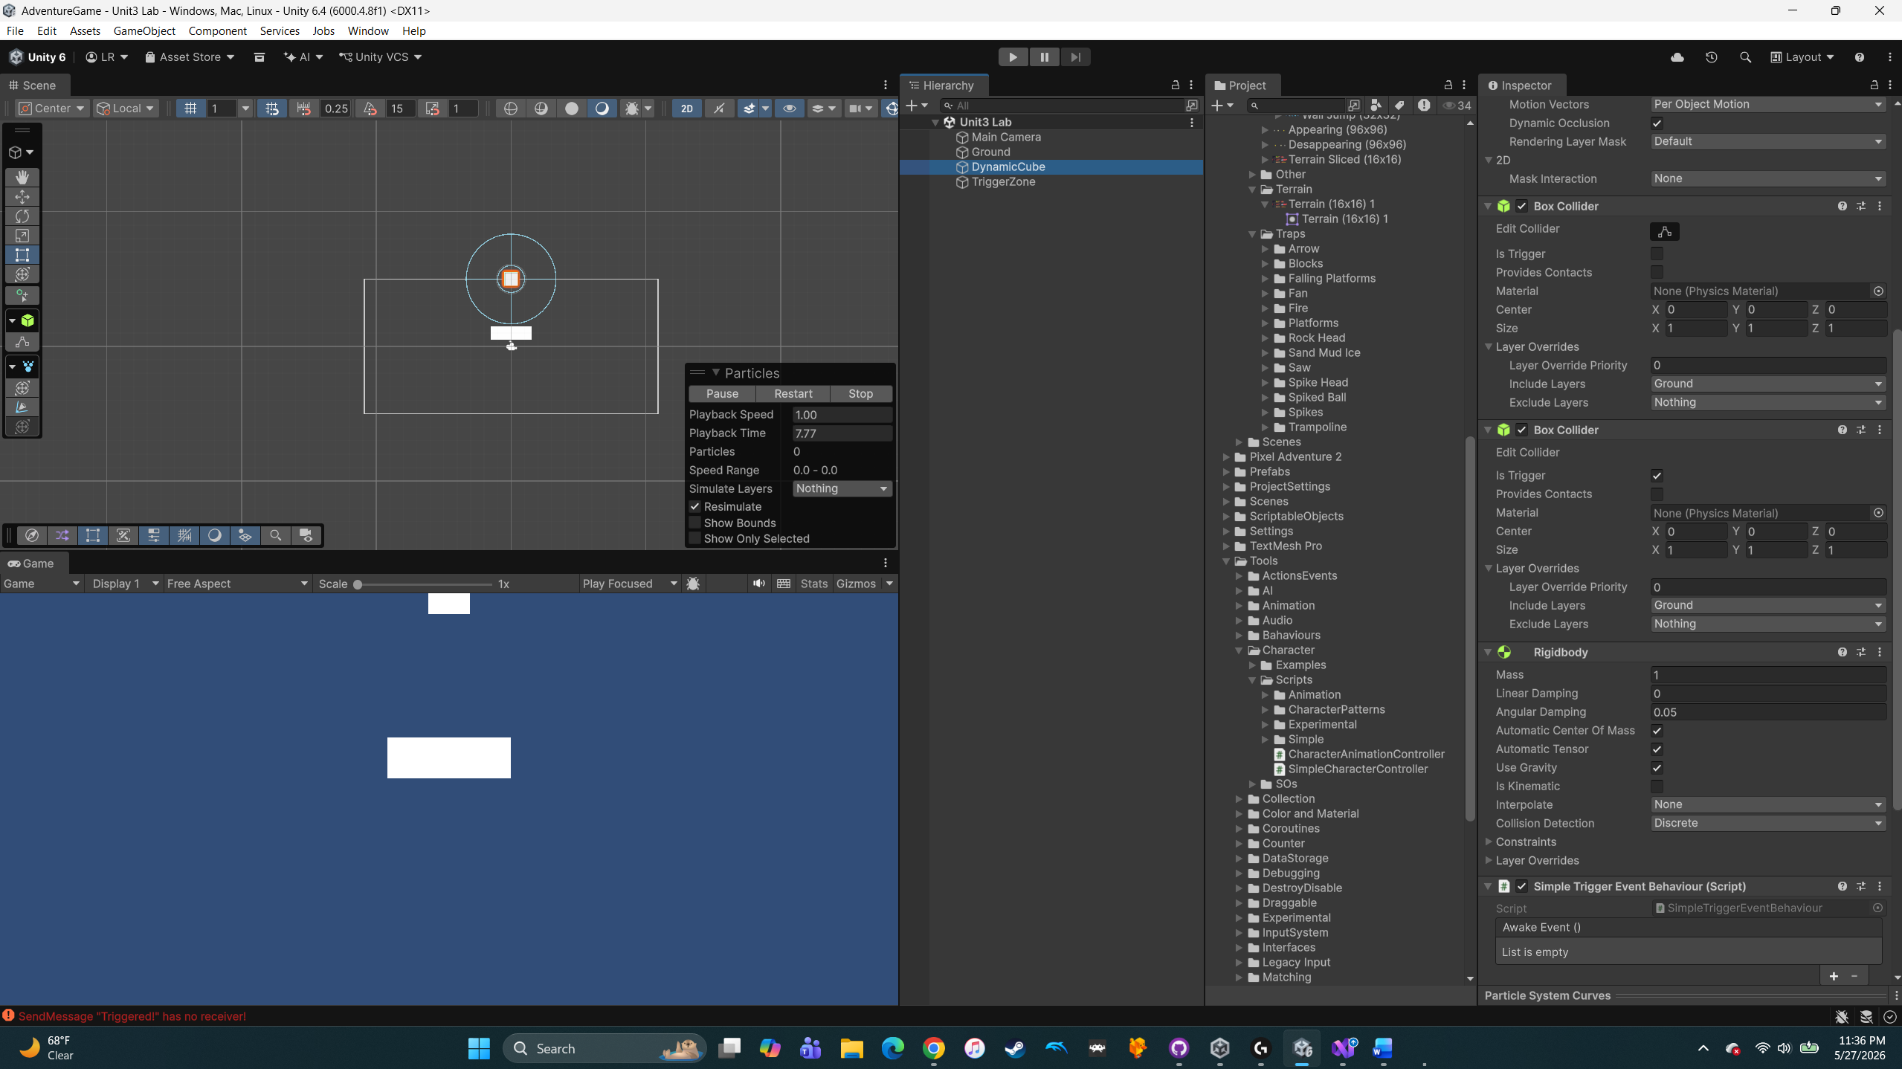
- Screenshot #2: Unity Inspector of TriggerZone showing BoxCollider (Is Trigger) and your custom script.
  - 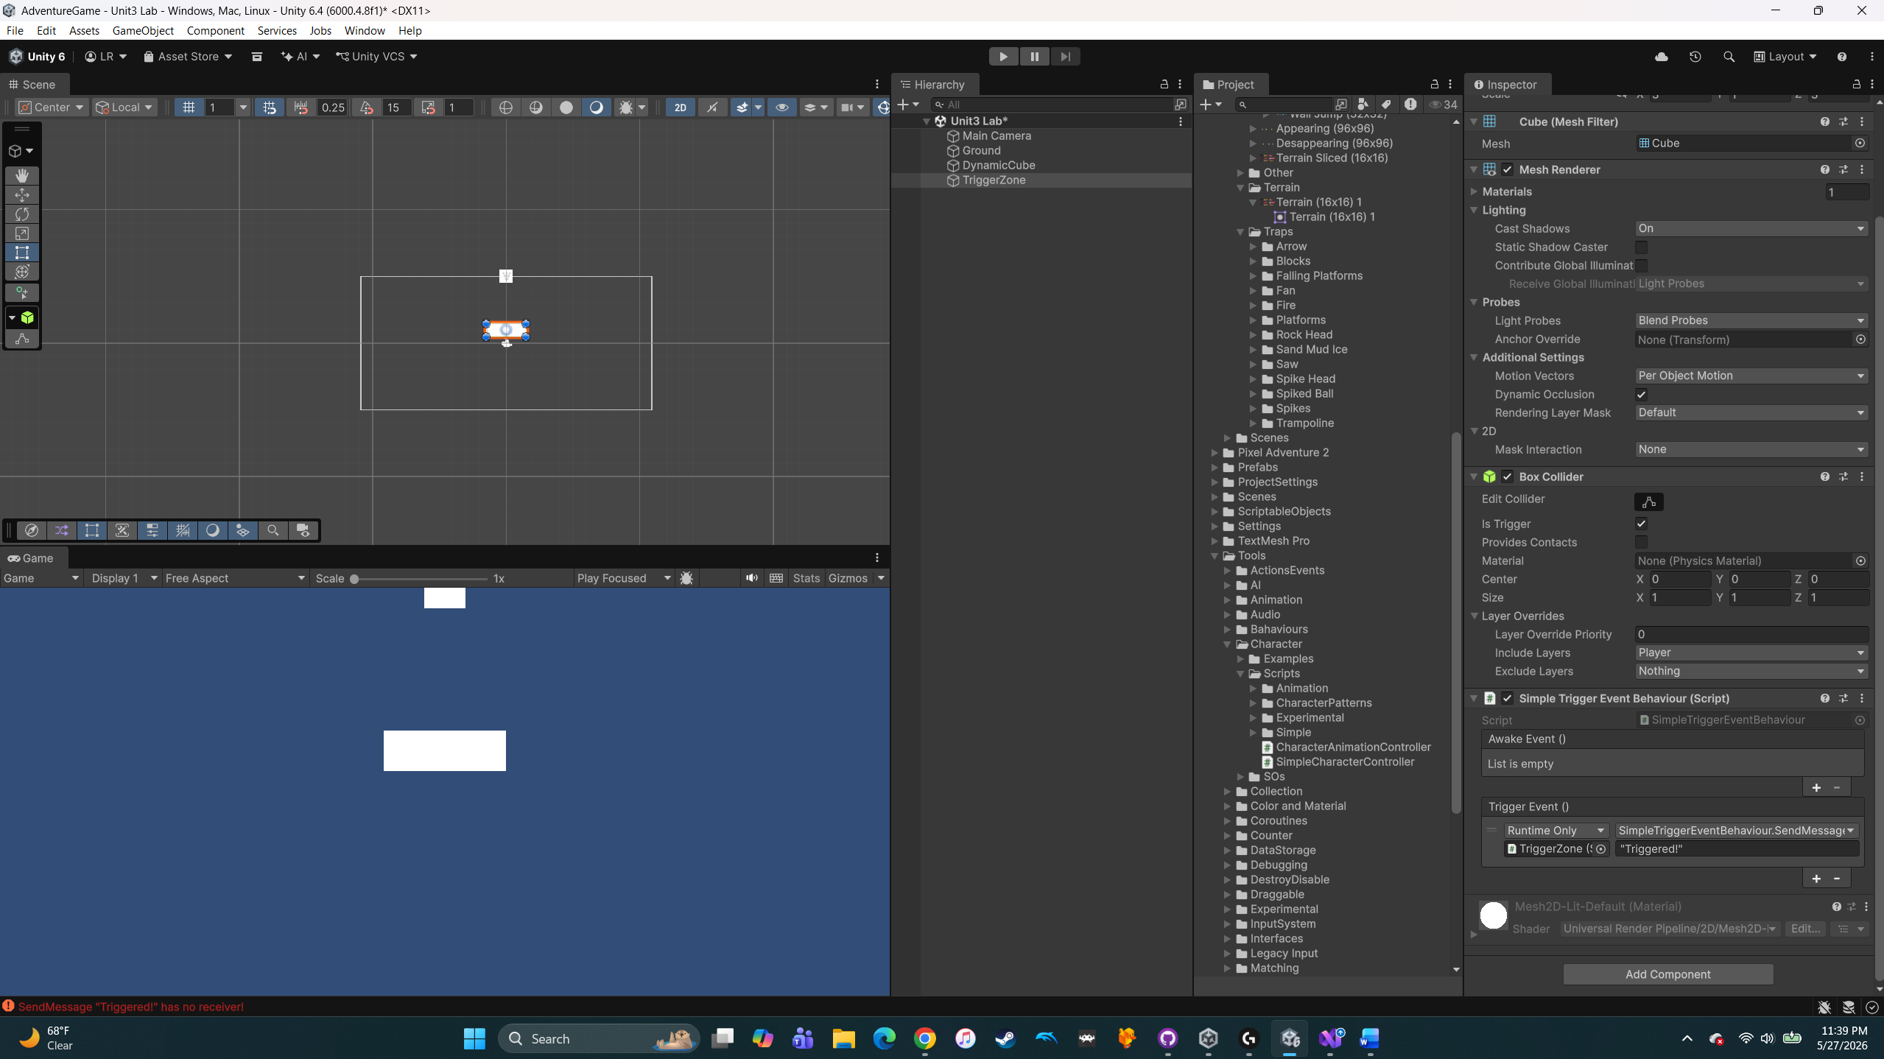
- Play Mode Screenshot: The moment DynamicCube enters TriggerZone (Console visible or color change/particles).
  - After Trigger: 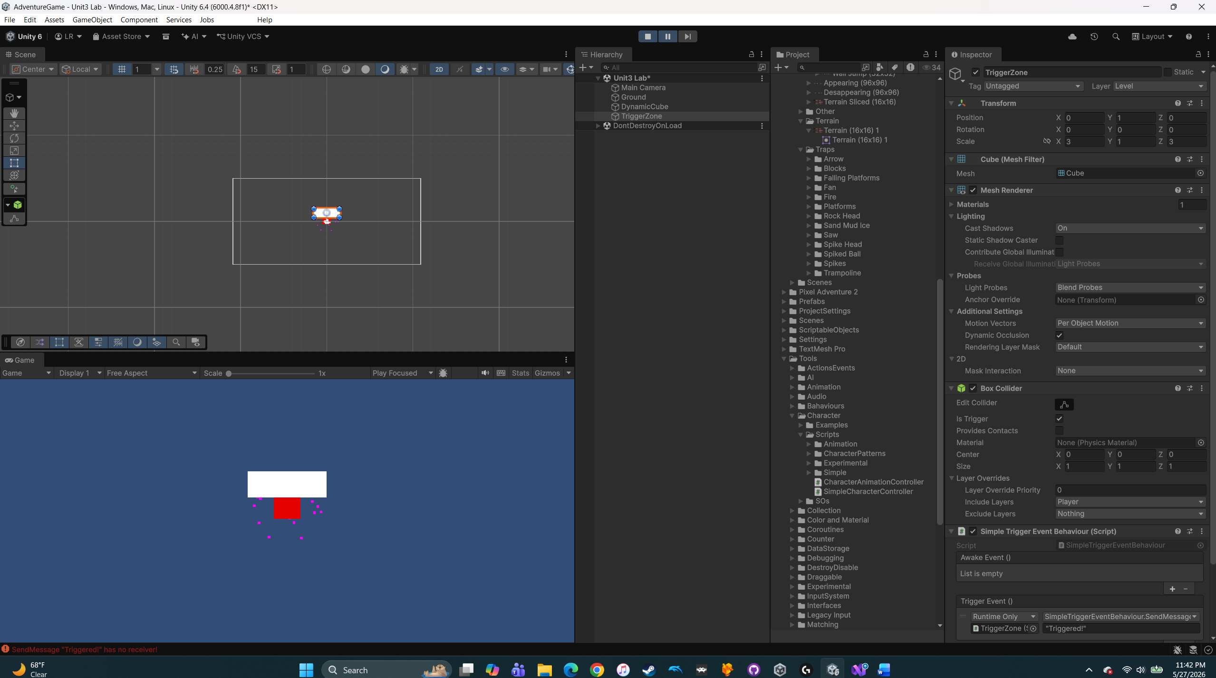
- Write-Up (≈200 words): Summarize your steps, explain how colliders vs. triggers differ, and describe your creative extension.
  - This lab was pretty fun. Did a ton of experimenting and pushing myself. I couldn’t figure out how to do the MonoBehavior, but I figured out how to make all the things happen with the “Simple Trigger Event”. I started out pretty frustrated that I couldn’t do the MonoBehavior, but watching the video, I decided the Simple Trigger Event was how I was going to do it. I figured out how to send the “Triggered!” message, initially attaching it to the DynamicCube. I then added the particle burst and change the color too. I then realized that the assignment wanted the “Triggered!” output to be attached to the TriggerZone, so that was an easy fix. The Dynamic Cube fell through the ground, so I had to adjust that like on the sample video. It was a very simple finished product, but man this was rewarding.
- GitHub URL: Link to your fork of the Essentials repo containing your commits for this lab.

